DFCT0014391

Scenario 1:When the previous term of the policy is cancelled and the renewal is already bound (Renewal is between the period 35th day to 0th day) A Systematic cancellation must be triggred on the renewal term too. This not working as accepted.(x-40)

Policy Number: AUT865050031

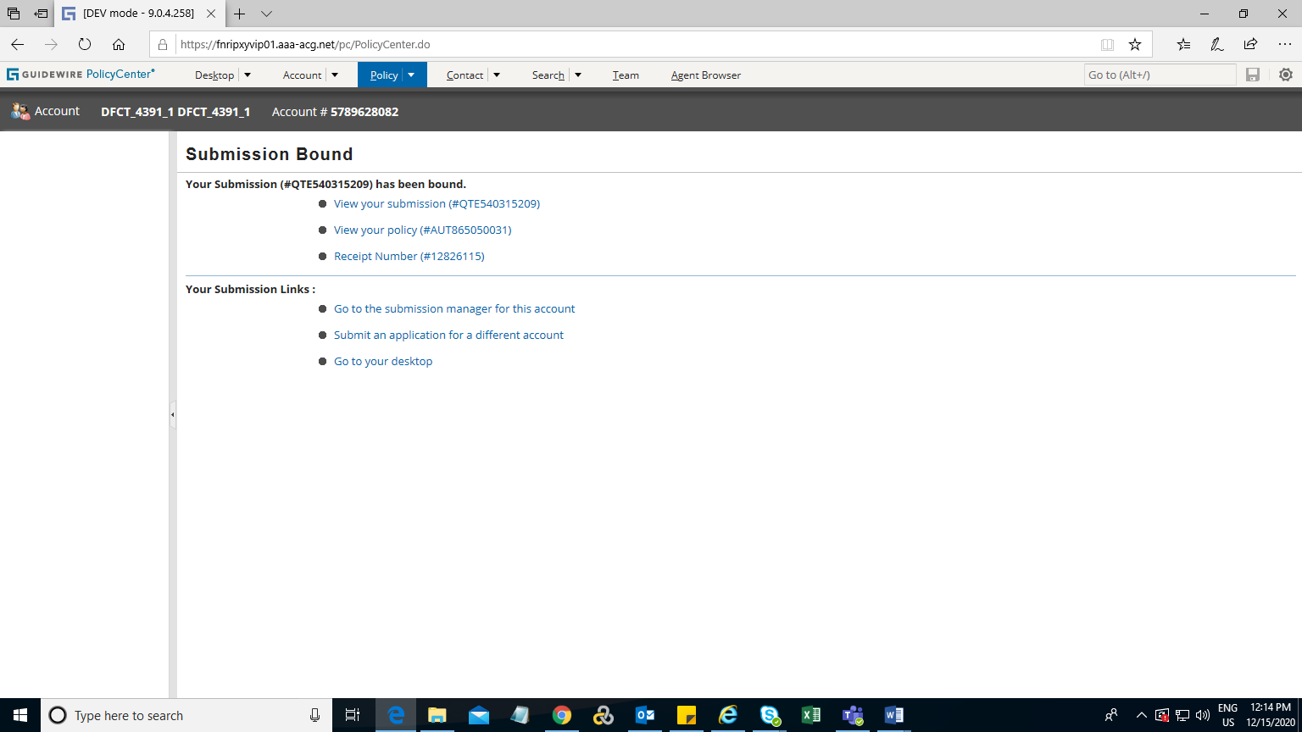

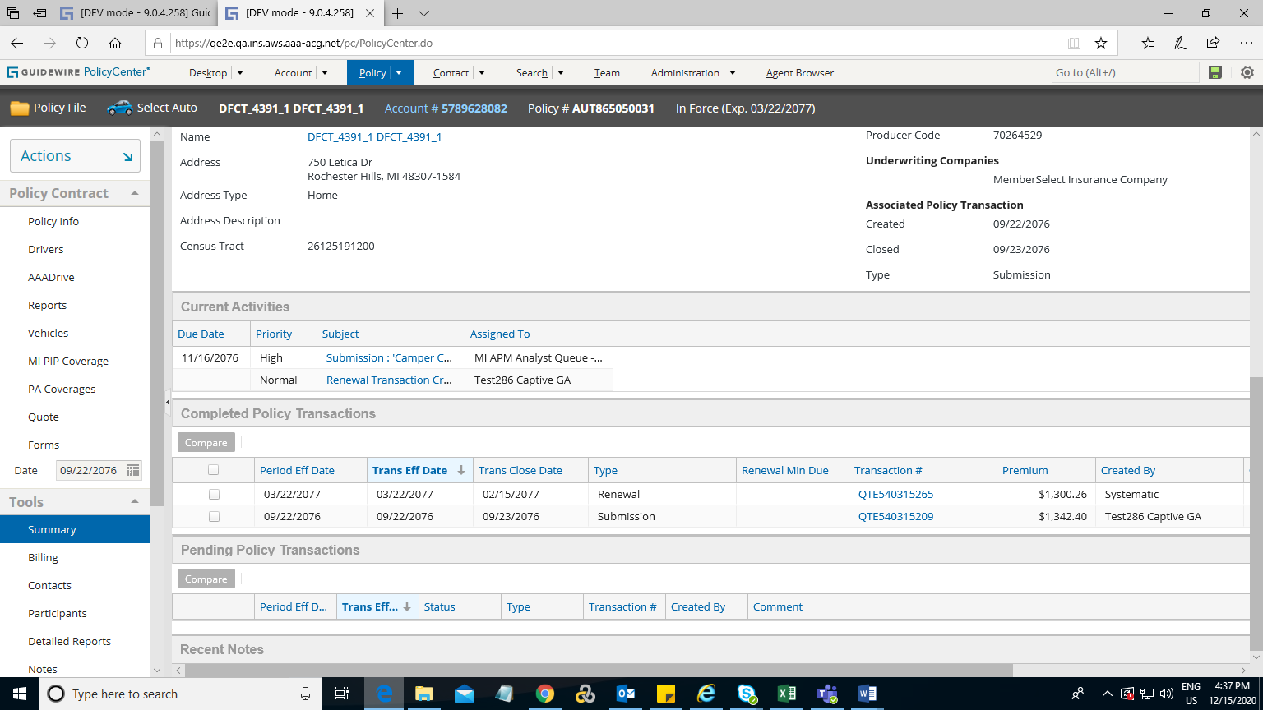

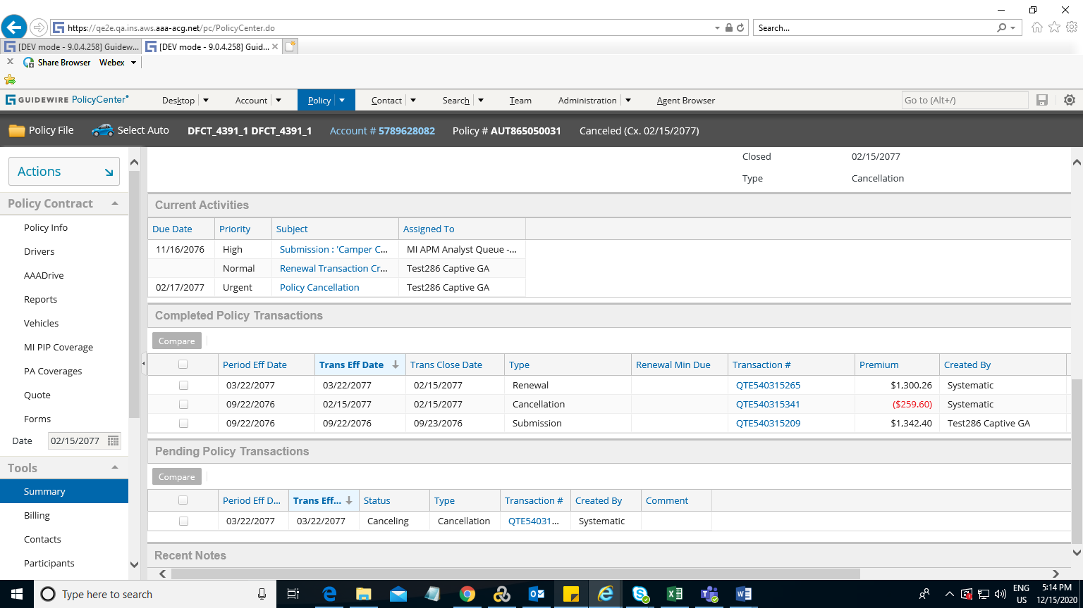

Scenario 2: When the previous term of the policy is cancelled and the renewal is in renewing status ,The renewal in renewing status must be withdraw .

But as per code the renewal is getting withdrawn( if the renewal notification date is null) ,or the renewal goes in non renewing status(if the renewal notification date is not null)) .(RenewalEnhancement --withdarwOrSetNonrenewal())(x-80)

Policy Number: AUT865050032

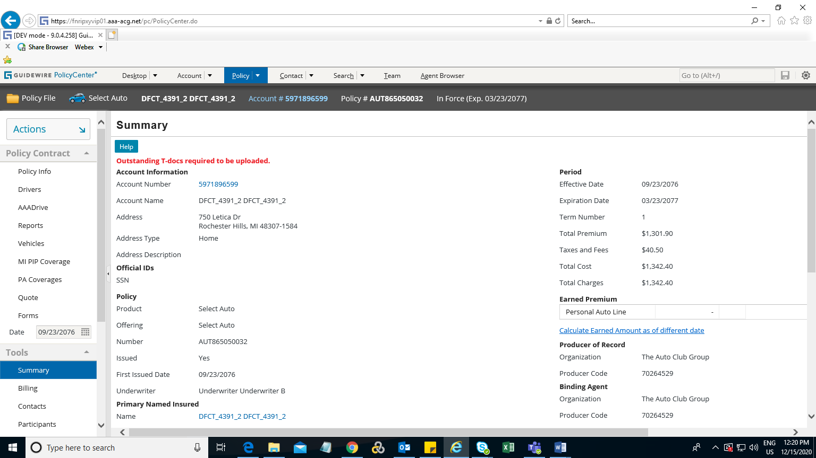

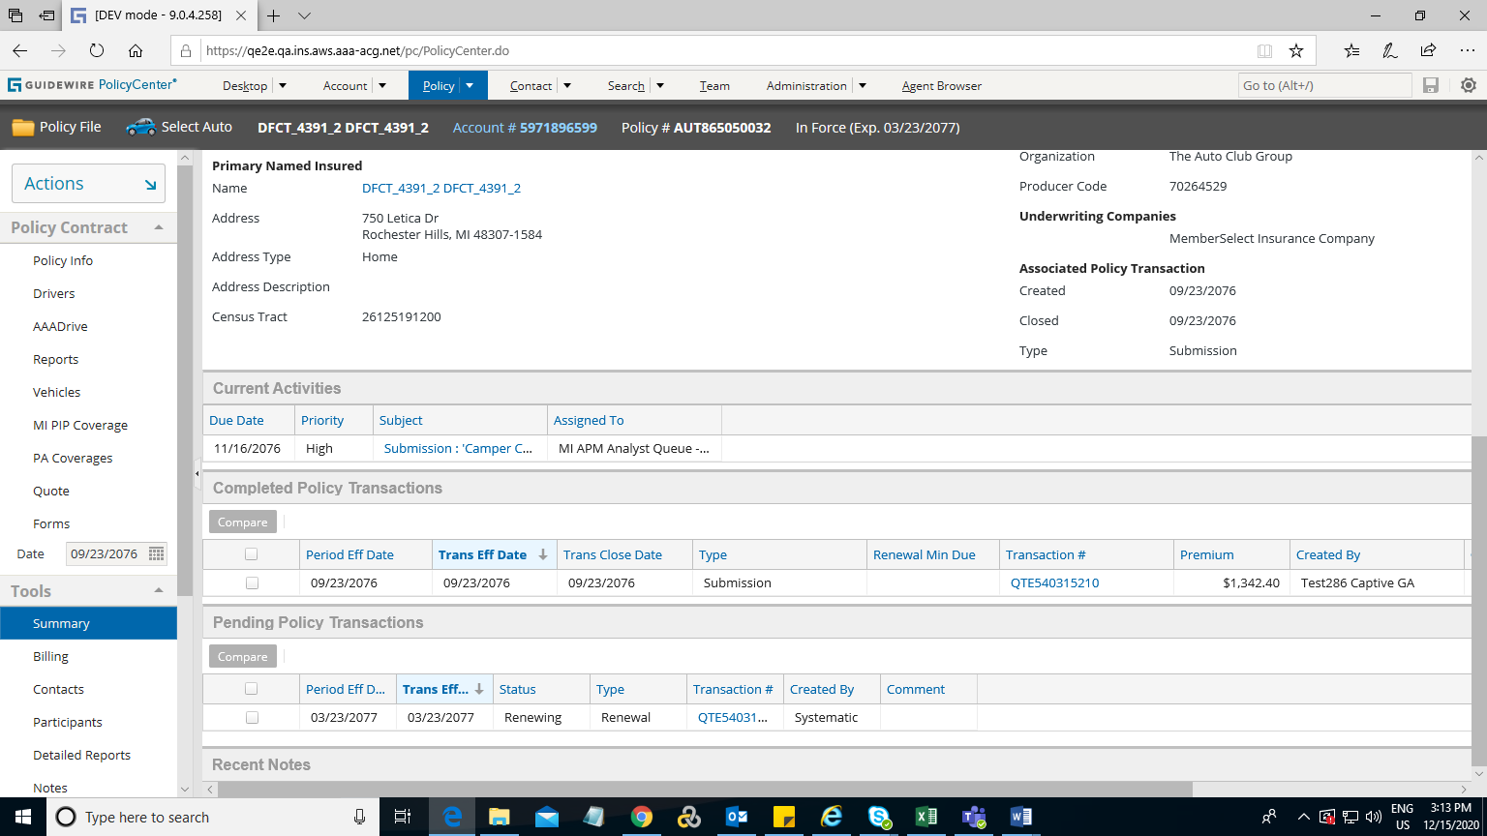

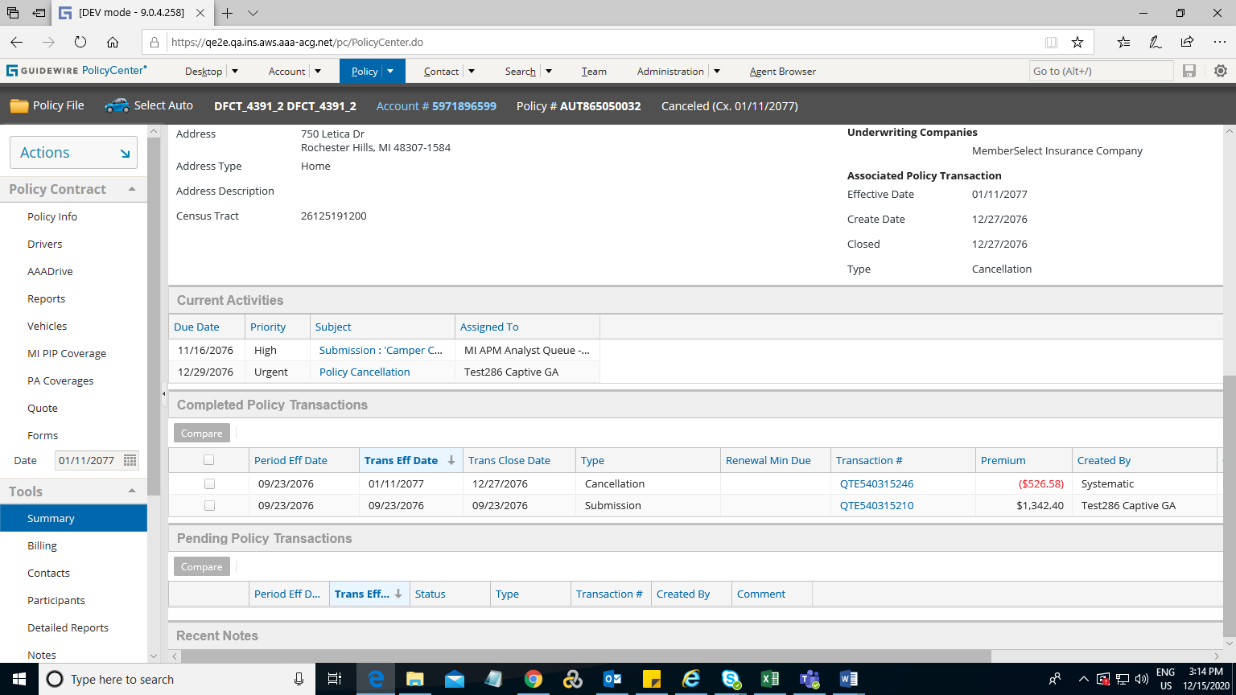

*Scenario 3: R*eprodusable

*1. Create a submission and bind the submission.*

*2. create x-85 renwal and do cancellation on x-70(scenario 2 will occur)*

*3. Do the Rewrite new term on x-60 and cancel the policy again on the same effective date(rewrite new term).*

*4. Perform Reinstate on the policy with Rewrite New Term effective date.*

*5. A systematic renewal will trigger even if it is not having x-85.*

Policy Number: AUT865050033

